# Before Beginning

* To write down the motor name plate.
* To know the feature of the motor (pump, conveying, fan)
* To know the regulation type on this motor

**When the G120 has safety integrated, the power contactor before the drive is deleted. This function allows safely stopping the motor and preventing the motor to start.**

**This is not an electrical disconnection. For any intervention on motor, we must put off the circuit breaker.**

Two devices compose a G120 inverter: one power device (power module PM240, PM250 or PM260) and one controlling device (control unit CU240S DP, CU240S DP-F,)



**Efficient Infeed drive inverter**

The PM250 integrates a filter and allows sending back current on electrical network.

The wiring on power module is only for the power input (U1, V1, W1 and ground) and the supply for the motor (U2, V2, W2 and ground). All other connections are on CU.

The CU240S DP-F is a CU with safety integrated. The communication between inverter and PLC is Profinet network.

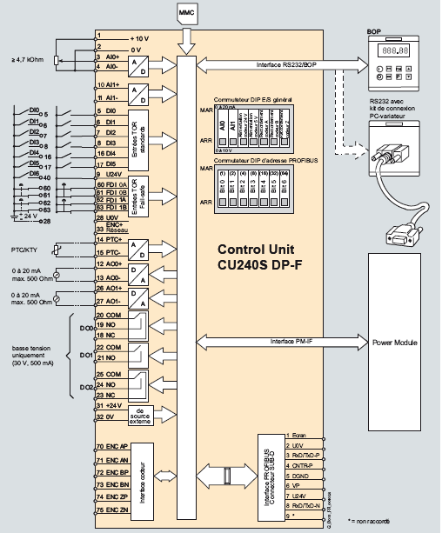

# Configuring the G120

During first use, remove the memory card if it’s empty. Indeed, with factory setting, the CU will try to download parameters from memory card.

If we forget, the fault F00064 appears.

Modify P8458 parameter to 0 to prevent cloning on first use.

## Operating panel description

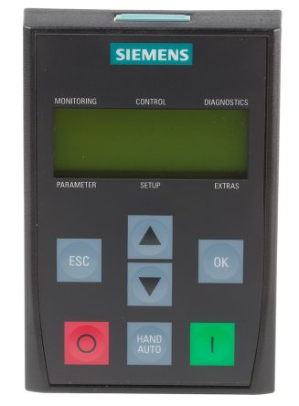

|  |  |  |  |
| --- | --- | --- | --- |
| **OP button** | **Function** | **Effects** | |
|  | Status bar | The LCD screen displays the actual parameters. | |
|  | Start motor | This button is used to start the motor. This function is inactive with factory settings. To activate it, select the manual mode. | |
|  | Stop motor | OFF1 | If this button is activated, the motor slows down according the ramp down time and stops. It’s inactive with factory settings; to activate it → see "Start motor". |
| OFF2 | If this button is activated one more time (or for a long time), the motor stop freely, without any ramp. This function is always active. |
|  | Enter | Press this button to enter values. | |
|  | Escape | Use this button as a back button. | |
|  | Manual/Auto | Use this button to activate manual or auto mode. | |
|  | Increase the value | Press this button increases the displayed value. | |
|  | Decrease the value | Press this button decreases the displayed value. | |

## Quick commissioning with TIA

These are the critical parameters to configure the G120 drive, Configuring these parameters completes the drives basic commissioning settings.

* p100 : Motor standard
  + 0 for European motor standard 50Hz, KW
  + 1 for American motor standard 60Hz, Hp
  + 2 for American motor standard 60Hz, KW
* p205 : Inverter application
  + 0 : high overload
  + 1 : low overload
* p210 : Supply voltage
  + Incoming supply voltage to the drive (480V) depends on customer location
* p300 : Motor type selection
  + 1 for asynchronous motor
* p304 : Nominal motor voltage
  + We need to enter the voltage corresponding on motor coupling. If we use 87 Hz coupling, we need to enter the « small » voltage. Generally, this voltage should be 230V
  + If we use standard frequency (50Hz or 60Hz) Use the voltage corresponding to that frequency mentioned in the motor name plate
* p305 : Nominal motor current
* p307 : Nominal motor power
* p308 : Motor power coefficient (cosine phi)
* p310 : Nominal motor frequency
* p311 : Nominal motor speed
* p335 : Motor cooling
  + 0 for Self cooling (Shaft mounted cooling fan)
  + 1 for Force cooled (Separately powered cooling fan)
* p400 : Encoder type
  + 0 disabled for V/f & Sensorless control
  + 2 Quadrature encoder without zero pulse for Vector control
* p408 : Encoder pulse number
* p410 : Encoder direction
  + 0 for Normal rotation
  + 1 for Reverse rotation (select this option when the phase sequence of motor is not matching with the encoder direction of rotation)
* P601 : Motor temperature sensor
* P601 : Motor temperature sensor
  + 0 no sensor
  + 1 for PTC sensor
  + 2 for KTY sensor
* p604 : Motor temperature threshold (normally 130°C)
* p610 : Motor thermic reaction I2t
  + 2 Warning & Trip
* P640 : Overload coefficient
  + 100% for good motor protection. To authorize motor to accelerate quickly, let the value calculated with starter.
* p700 : Source selection command
  + 6 for bus command (Fieldbus)
* p727 : Start / stop / reverse command selection
  + 0 for “normal” selection
* p1000 : Setpoint source selection
  + 6 for setpoint from bus (Fieldbus)
* p1080 : Minimum frequency
* p1082 : Maximum frequency
* p1120 : Ramp up time
* p1121 : Ramp down time
* p1135 : OFF3 ramp
* p1200 : Flying start
  + 0 for Flying start disabled
  + 1 for Flying start always active
* p1300 : Command mode
  + 1 for pumps and fans applications (V/f control)
  + 20 for transport applications without encoder (Sensorless vector control)
  + 21 for transport applications with encoder (Vector control with sensor)
* p1460 : Gain for Vector control
* p1462 : TI for Vector control
* p1470 : Gain for SLVC
* p1472 : TI for SLVC
* p1500 : Torque setpoint selection
  + 0 for no torque selection
* p1900 : Motor data Identification
  + 2 for identification with motor stopped
  + 3 for identification with motor stopped and saturation curve.

The alarm A0941 is appearing, then we need to launch start order for parameters identification. When it’s finished, the alarm disappears.

* p2000 : Reference frequency

### **Step by Step procedure to configure drive basic commissioning parameters using TIA:**

Connect on the drive (Select the target device then connect to target device) with TIA PORTAL.

Select the Drive 🡪 Commissioning 🡪 Commissioning Wizard.

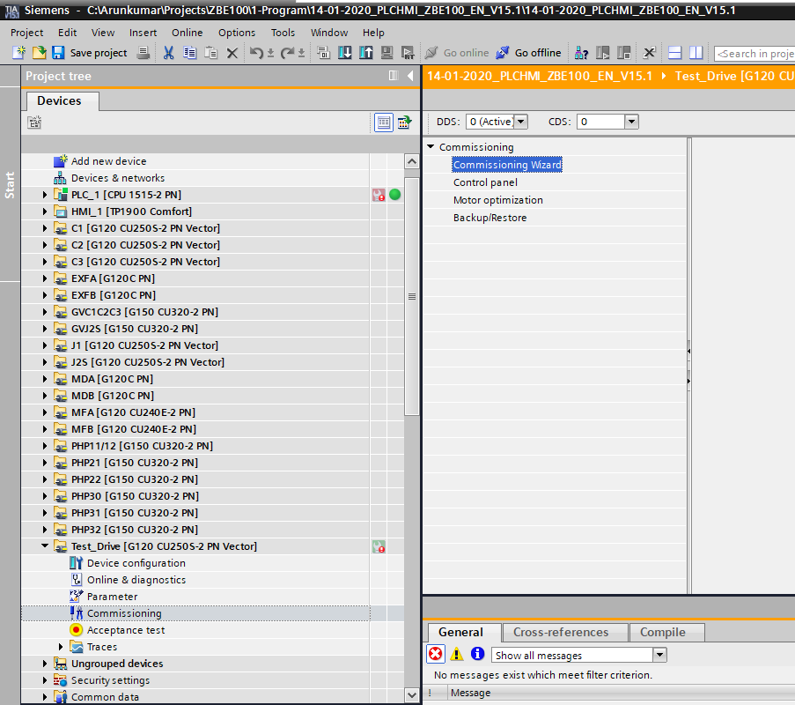

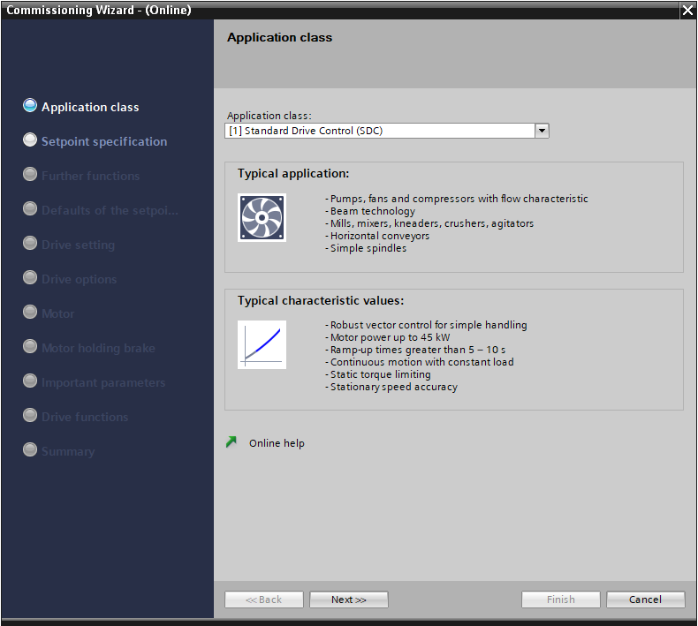

**Step 1:** Select the Application Class:

Select Application Class 🡪 Expert

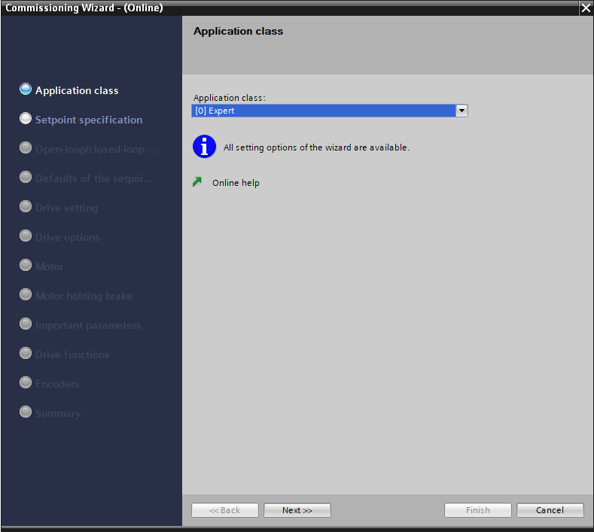

**Step 2:** Select the Controller connection and Setpoint Specification.

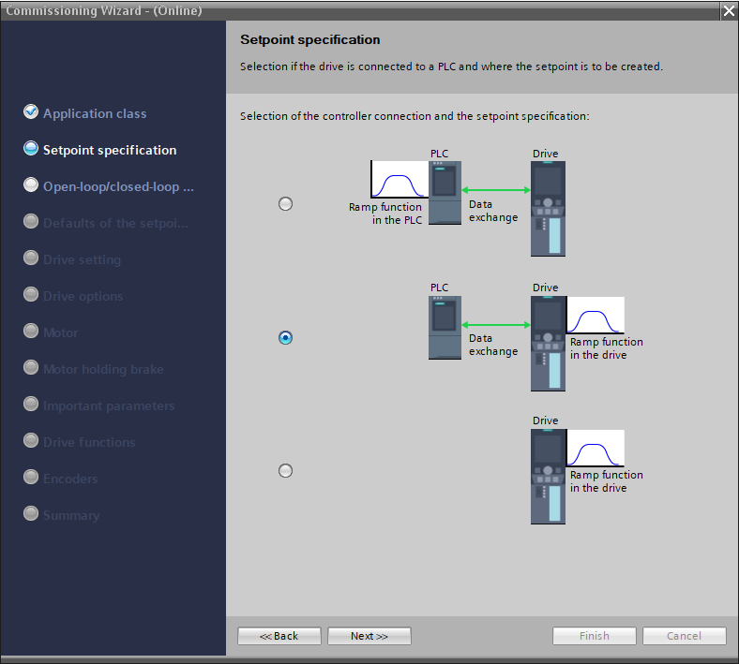

**Step 3:** Selecting the control type.

* For Transport Inverters, Select 21–Encoder or 20–Encoderless
* PHP, GV, MF and Others select 0 – U/f.

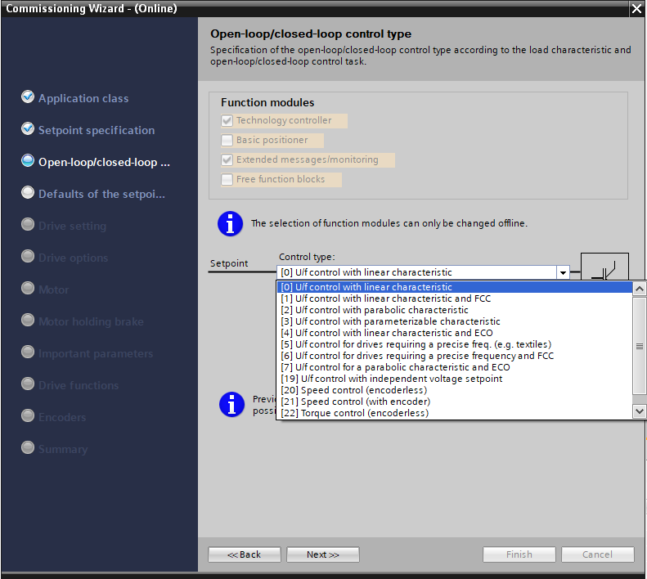

**Step 4:** Selecting the command source, the default selection is [7] Fieldbus with data set changeover. Telegram configuration is [999] Free Telegram configuration with BICO.

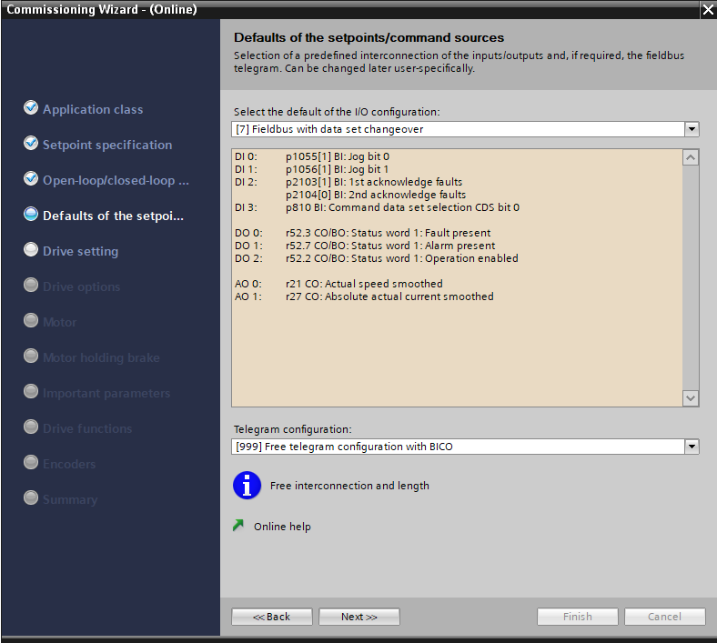

**Step 5**: Select the drive properties based on motor nameplate

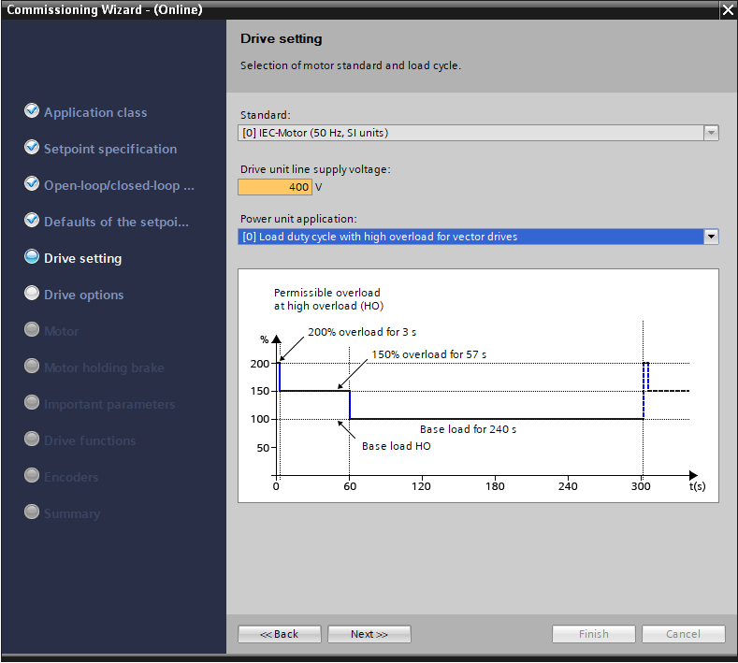

**Step 6:** Select Braking resistor and Filter type.

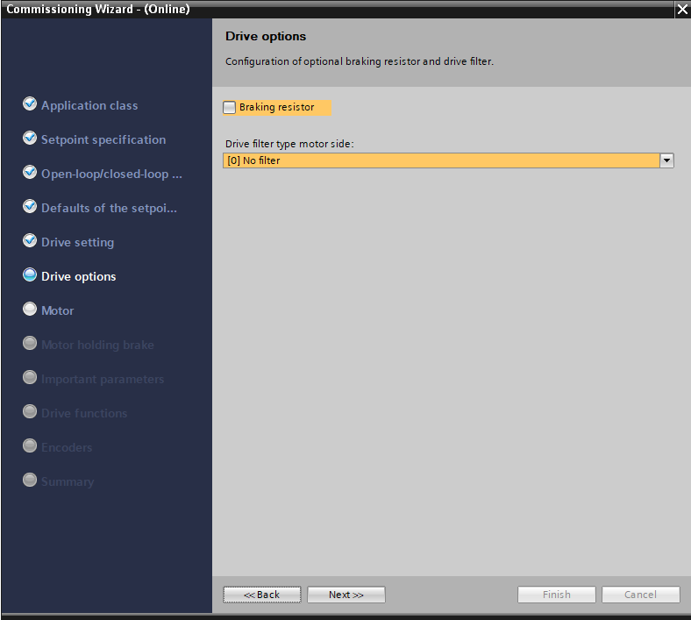

**Step 7:** Select the motor type and enter the Motor data. Normally Induction Motor and Select PTC Alarm and Timer.

Motor Cooling Type:

For transport 🡪 Forced Cooling/ If we installed a separate cooling fan.

For others 🡪 Natural Ventilation.

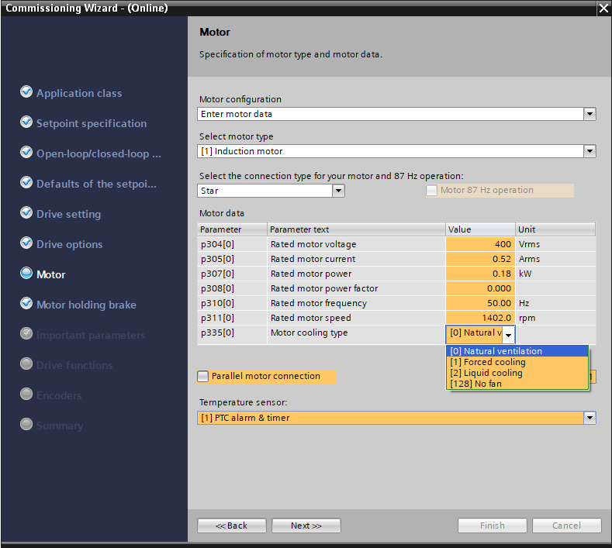

**Step 8**: Brake Configuration.

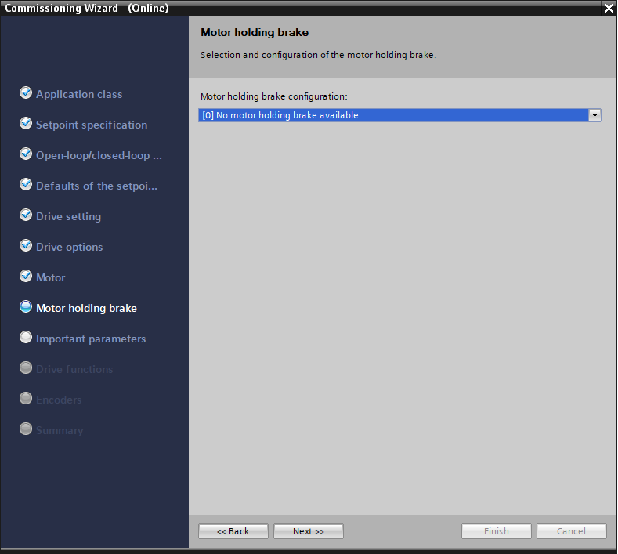

**Step 9**: Enter the Speed, Ramp up and down time and Maximum Current limit.

For GV & Fan Motors Set Ramp up – 60s & Ramp down -120s

For Transport, Pumps Set Ramp up – 10s & Ramp down -10s

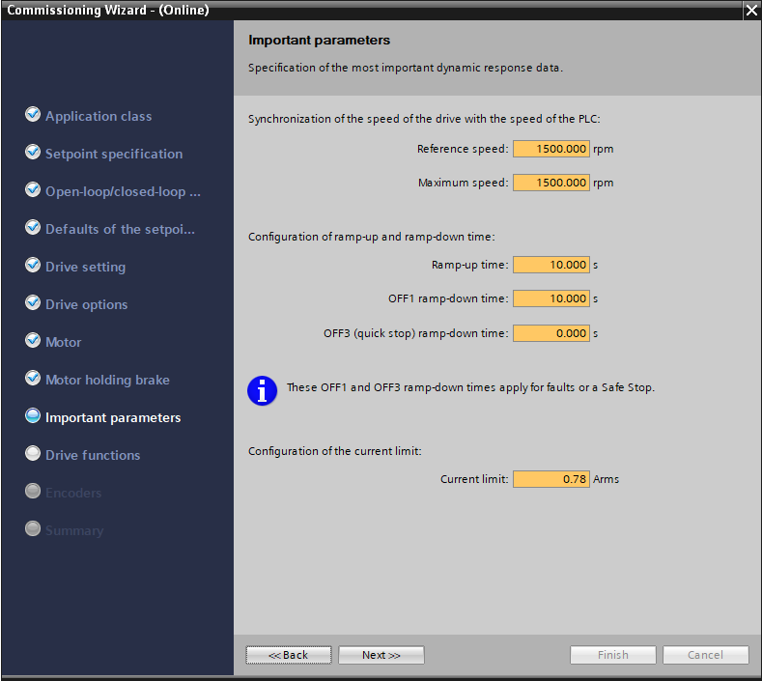

**Step 10:** Select the Drive Functions.

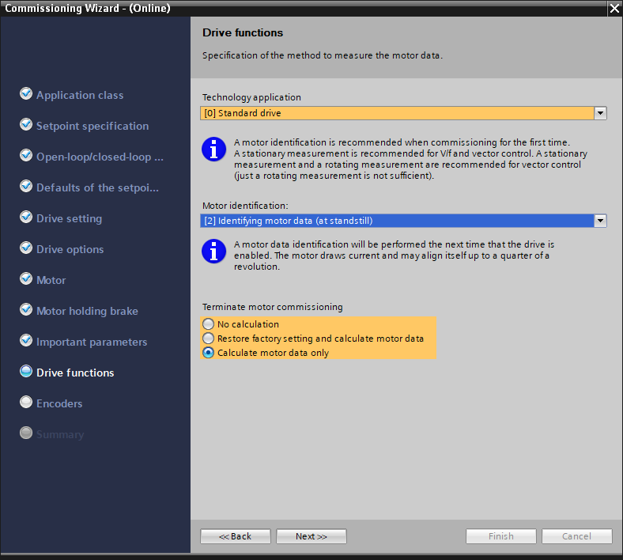

The A0541 alarm is appears as soon as you enable the Motor identification.

Motor identification procedure starts when you start the motor for the first time after completing this commissioning parameter configuration procedure.

After completing the parameter configuration, Open the command panel and launch the start order.

The motor identification starts. When the motor identification is completed successfully, the motor automatically stops and the alarm disappears.

**Step 11:** Select the encoder type if you are using.

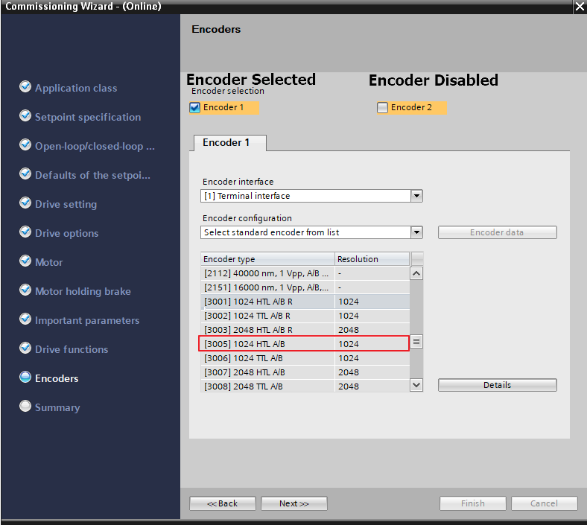

**Step 12:** On last window, check the «Copy RAM to EEPROM » and then Click Finish

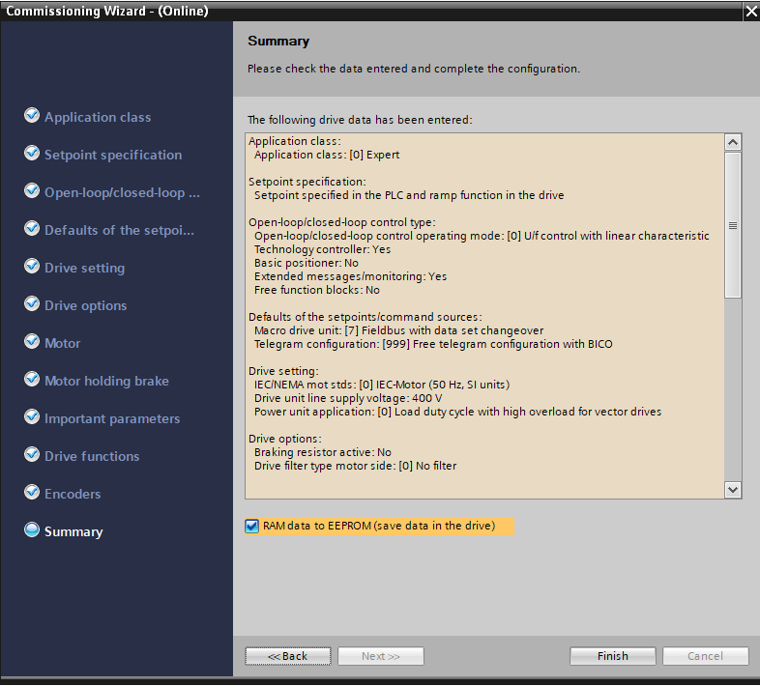

The parameters will get downloaded into the ROM memory of the drive.

After completing the above 12 steps, Check for the following parameters in Drive 🡪Parameter🡪 Parameter View.

p 208: Supply Voltage

p 400: Encoder direction

p 601: Motor temperature sensor

p 604 & p 610: Temperature and Motor reaction

p1200: Flying restart

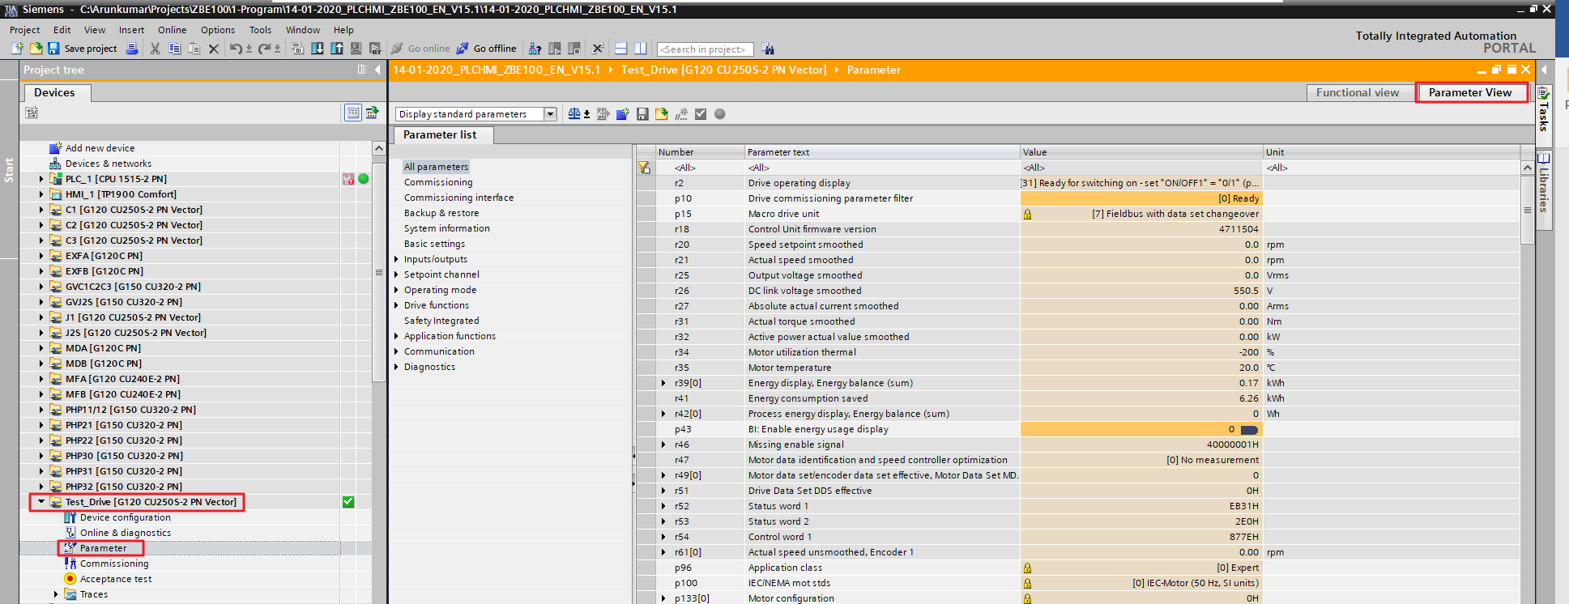

After validating this start the Motor Identification procedure by starting the motor from Control panel. (Refer explanation in Step7)

## Functioning with 87Hz coupling

When we want to use the 87Hz curve of the motor, we can use directly STARTER to put the parameters at this frequency.

Check that motor tolerates the adequate voltage (generally 400V).

Check that wiring on the motor is done on small tension (generally 230V).

Then put motor characteristics with 50Hz and small tension. Don’t select 87Hz option in commissioning mask.

Modify through parameter list following parameters:

* P1082 = 87 Hz
* Px = 87 Hz

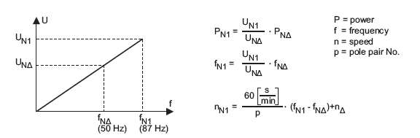

## Adaptation of linear speed

Check the real speed of the roll then deduce p2000 parameter that adjusts 100% of PLC setpoint.

During a test with p2000 = 87, the speed setpoint is 600m/min and the measure is 560m/min.

p2000 = speed setpoint * p2000 value during test / speed measure

p1082=p2000 = 600 * 87 / 560 = 93.21

Modify the parameter p1082 & p2000 then do the test again. To have more precision, the test must be done at maximal speed.

## Motor temperature monitoring setting using Starter

* P601 : Motor temperature sensor
  + 0 no sensor
  + 1 for PTC sensor
  + 2 for KTY sensor
* p604 : Motor temperature threshold
* p610 : Motor thermic reaction I2t

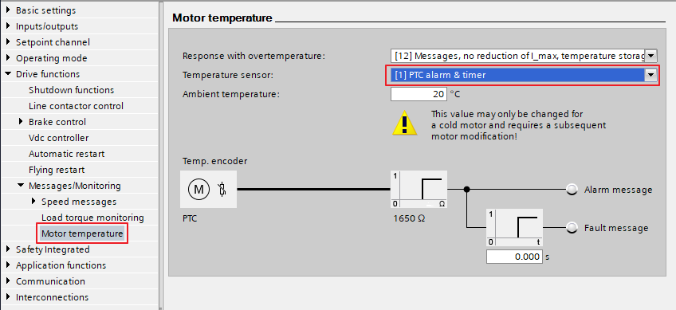

## Encoder Connection terminal

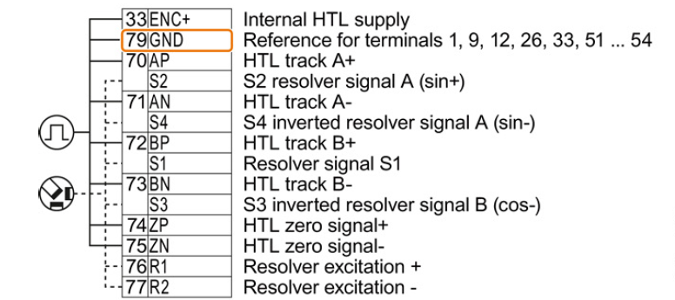

* r0061 : Rotor speed
* R0090 : Rotor angle du rotor
* P0400 : Encoder type
  + 0 no encoder
  + 2 encoder with A / B signals
  + 12 encoder with A / B / 0 signals
* r0403 : Encoder state word
  + Bit 0 encoder device active
  + Bit 1 encoder fault
  + Bit 2 Signal OK
  + Bit 3 Encoder failure, low speed rotation
  + Bit 5 Measure on one channel
* p0408 : Round pulse number
* p0491 : Attitude if encoder failure
  + 0 Don’t go to SLVC mode
  + 1 Go in SLVC mode allows the motor to continue running in open loop with A0590 alarm. When the motor stops, the fault F090 appears.
* p0492 : Gap rotation speed admissible
* p0493 : Difference of rotation speed
* p0494 : Timer for speed response loss
* p1300 : Command mode
  + 1 for pump or fan applications
  + 20 for transport without encoder application
  + 21 for transport with encoder application

## Improvement of speed regulation

In case of regulation with vector control (p1300>=20), it’s possible to improve the speed regulation.

Set p1960 = 1 causes alarm A0542.

Give start order, the speed optimization starts.

When the optimization is finished, the p1960 parameter goes back automatically to 0.

The parameters p1460 and p1462 or p1470 and 1472 will be modified.

The optimization may be launched several times to have best results.

However, the optimization function can be adjusted manually.

* p1460 : Gain speed regulator with close loop
* p1462 : Integral time speed regulator with close loop
* p1470 : Gain speed regulator with close loop without encoder
* p1472 : Integral time speed regulator with close loop without encoder

## Fan command

The inverter inputs/outputs can be set by user.

The parameters p731 to p733 match to relay outputs 0 to 2.

P732 = r52.2 (motor running)

The parameters p701 to p706 match to digital inputs 0 to 5 for direct use.

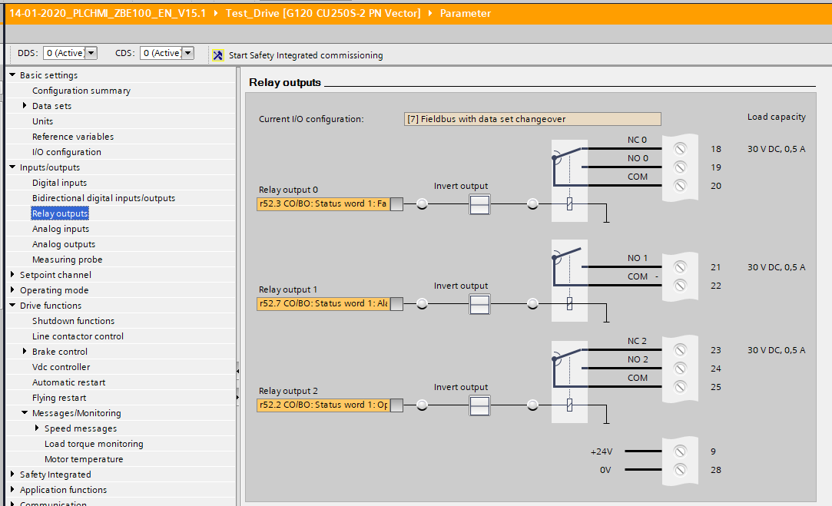

Here the Drive running signal r52.2 is assigned to relay output 2. The Terminal contact of the drive ’21 & 22’ closes when the drive is running. This contact can be used to connect the fan motors start signal.

## Flying restart

The parameter p1200 defines the flying restart.

* + 0 flying restart inactivated
  + 1 flying restart active

# Control Command

## Inverter parameterization

If we need to exchange more than 2 words state/command between PLC and inverter, we have to modify p922 (Selection of standard telegram).

The value must be the same in TIA & Start drive.

* P922
  + 1 Standard telegram PZD 2/2
  + 20 Standard telegram PZD 2/6
  + 350 Siemens telegram 350 PZD 4/4
  + 352 Siemens telegram 352 PZD 6/6
  + 999 free telegram (352 under TIA)

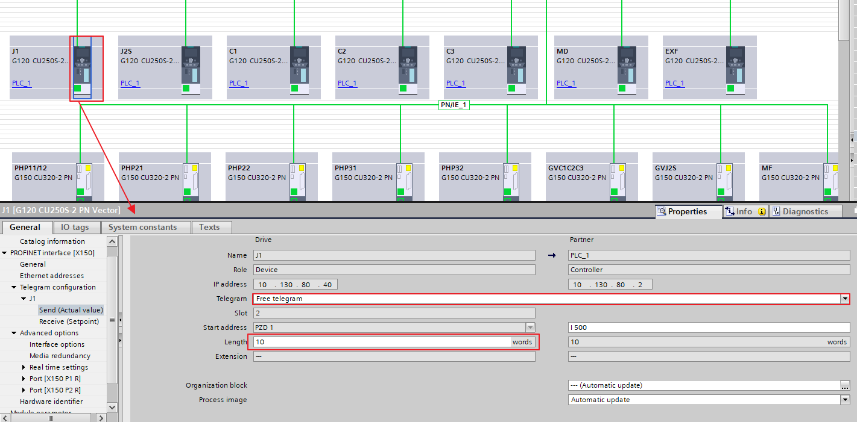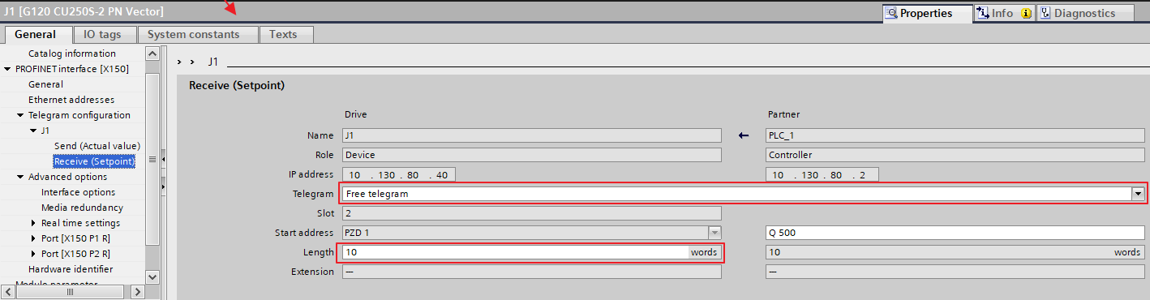

Check that the inverter is set for command by bus.

* p700 : Selection of command source
  + 6 for fieldbus command
* p1000 : Selection of setpoint source
  + 6 for fieldbus setpoint

In TIA go to the Parameter screen of the selected drive and then select the message frame Free BICO connections.

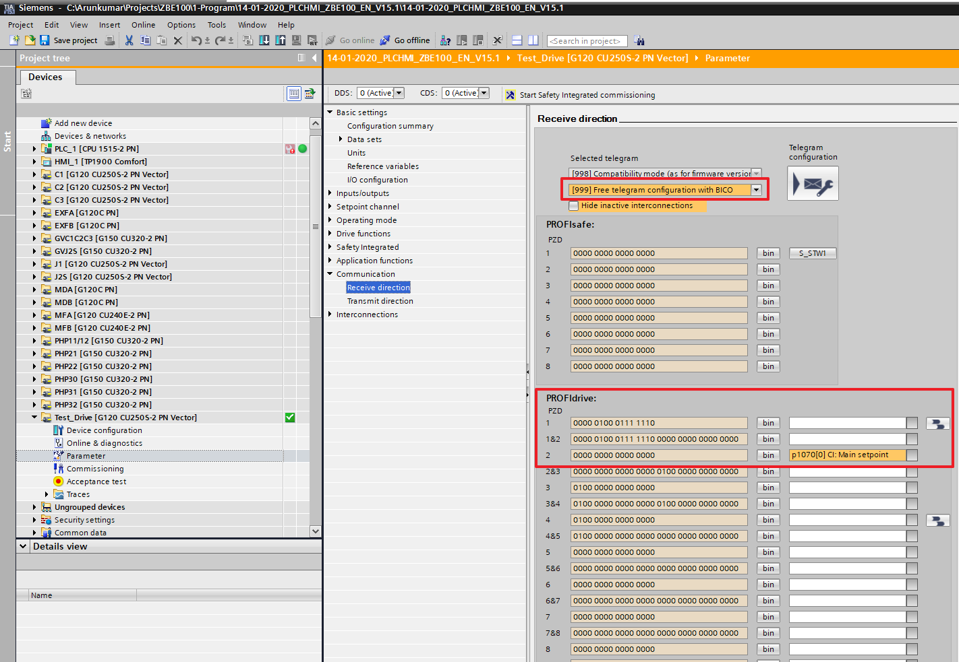

Receive direction tab the Command word is a Default setting. No need to change this

P1070 Main setpoint in 2

## Exchange between PLC and inverter

p2051 [0]: r52 (Inverter state word)

p2051 [1]: r21 (Speed measure)

p2051 [2]: r80 (Torque measure)

p2051 [3]: r27 (Current measure)

p2051 [4]: r2131 (Fault code)

p2051 [5]: r2132 (Alarm code)

p2051 [6]: r32 (Power measure)

p2051 [7]: r9734 (Safety Status)

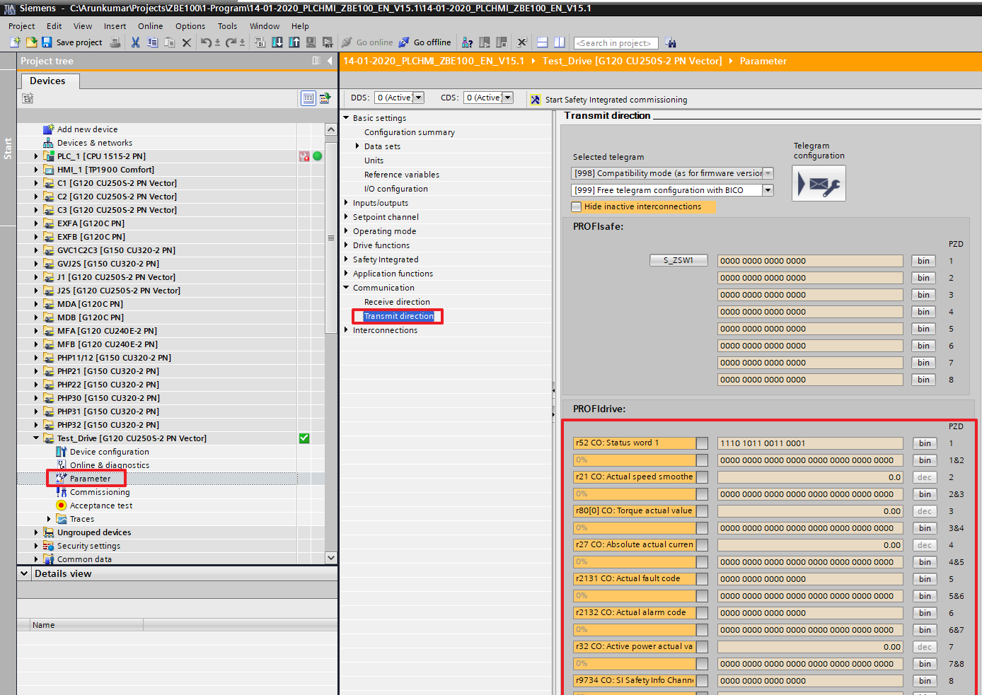

## Description of command and state words

State word: r52

Bit0: Ready for switching on

Bit1: Ready for operation

Bit2: Operation enabled

Bit3: Fault present

Bit4: Coast to standstill not activated (OFF2)

Bit5: Quick stop not activated (OFF3)

Bit6: Switch-on locked

Bit7: Alarm present

Bit8: Speed deviation within tolerance range

Bit9: Master control requested

Bit10: Maximum speed reached or exceeded

Bit11: Alarm: Motor current/torque limit reached

Bit12: Motor holding brake active

Bit13: Motor overload

Bit14: Clockwise rotation

Bit15: Inverter overload

Command word: p1070 (0)

Bit0: ON

Bit1: Coast to standstill (OFF2)

Bit2: Quick stop (OFF3)

Bit3: Enable operation

Bit4: Disable ramp generator function

Bit5: Inhibit ramp generator function

Bit6: Enable setpoint

Bit7: Fault acknowledgment

Bit8: JOG1 on

Bit9: JOG2 on

Bit10: PLC control

Bit11: Setpoint inversion

Bit12: Not used

Bit13: Motorized potentiometer UP

Bit14: Motorized potentiometer DOWN

Bit15: Dataset changeover

Safety word: r9734

Bit0: Safe torque off (STO) activated

Bit1: Safe Stop (SS1) activated

Bit2: Reserve

Bit3: Reserve

Bit4: Safety limited speed (SLS) activated

Bit5: Reserve

Bit6: Safety limited speed (SLS) Selected

Bit7: Internal event

Bit8: Reserve

Bit9: Select SLS bit0

Bit10: Select SLS bit1

Bit11: Reserve

Bit12: SDI Positive selected

Bit13: SDI Negative selected

Bit14: ESR retract requested

Bit15: Reserve

# Safety Integrated Management

Any modification on safety program can be done only when we’re connected online on the drive with TIA Start drive.

Using the TIA Start drive mask is easier. Indeed, the parameters are redundant. For each value, we have two values with different scales (ex in Hz and KHz) but the value has to be identical.

During parameters modification, the checksum should be the same. If there’s a difference, see again all parameters, it should have one difference between the two channels.



## Description of the Safe Stop function (SS1)

The safe stop function allows doing a control stop of category 1 according EN 60224-1. After activation of SS1, the drive brakes autonomously following a configurable ramp monitored and activate automatically functions STO and SBC under 2Hz.

If the drive doesn’t follow the configurable ramp after activation of SS1, the functions STO and SBC are activated immediately.

Application, advantages

This quick braking integrated function allows removing monitoring external devices. Frequently, we could renounce to mechanical brakes that can be damaged.

Safe Stop 1 is used for applications that require a controlled deceleration.

Functioning principle of safety integrated.

Two independent cutting circuits exist. All these circuits are active to low state. Then we are sure that on device failure or disconnection of wire, the drive is always going to safe status. In case of fault detection in cutting circuit, the STO function is activated and the switching to power on is locked.

Monitoring structure with two channels

All the hardware and software important functions on safety integrated are separated in two independent monitoring channels (by example the disconnection circuits, the data storage, the data comparison). The data relative to the safety in the two monitoring channels are periodically cross checked.

Dynamization required

To satisfy the requirement to EN954-1 and CEI 61508, the functions and the two disconnecting circuits must be tested periodically. This test can be automatic or manual.

## Step by step Procedure for assigning Safety parameters using TIA:

This view resumes the all safety functions settled in the inverter. To modify a parameter, the drive has to be stopped.

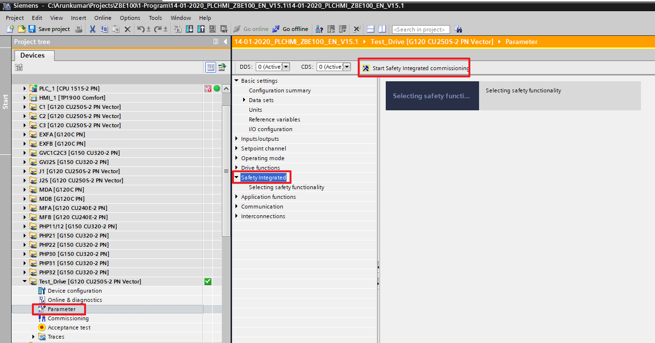

To start the Safety Commissioning Click the ‘Start Safety Integrated Commissioning, and A popup appears to set password.

The default password is 0. And change the password to ‘2311’.

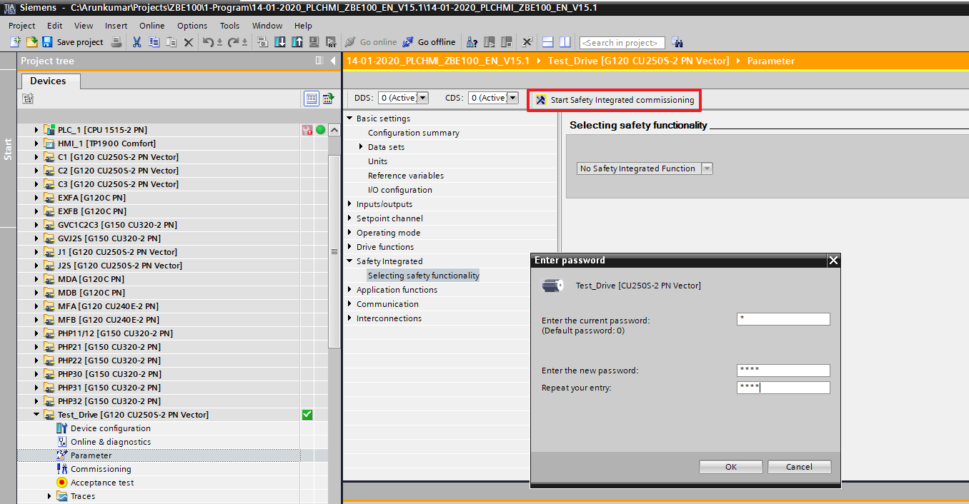

There are two types of safety,

Extended 🡪 Transport

Basic 🡪 Others.

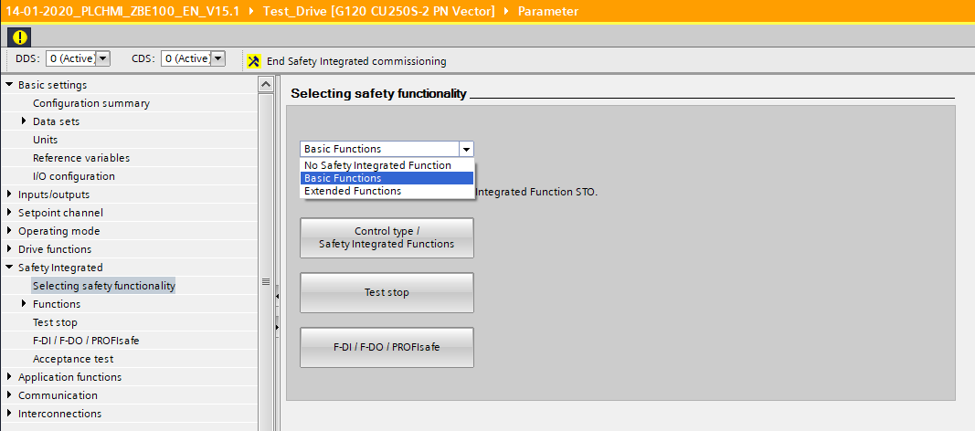

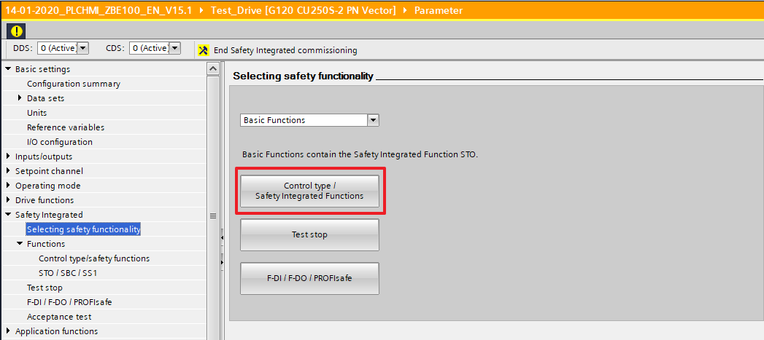

Select the Safety Contol type and Configure the STO/SBC/SS1.

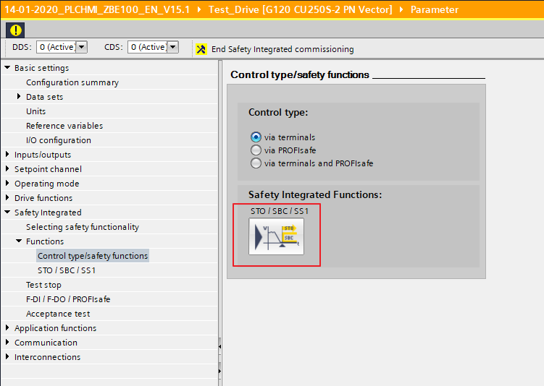

We can use the timer to break the OFF3 time

(i.e) If OFF3 ramp time 10s by entering 5s here will deramp the output till 5s and then sets the STO alarm and stops the motor immediately.

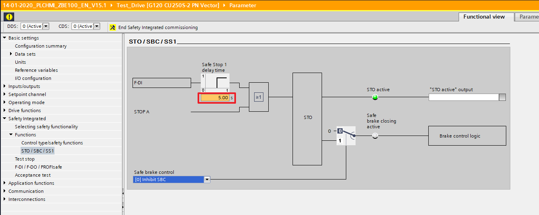

In the Test stop option we can program the time interval for the test stop, for correct shutdown.

Enter the number hours and within this hour the safety needs to be checked or else it will give an alarm. Automatically the given hours is changed as days.

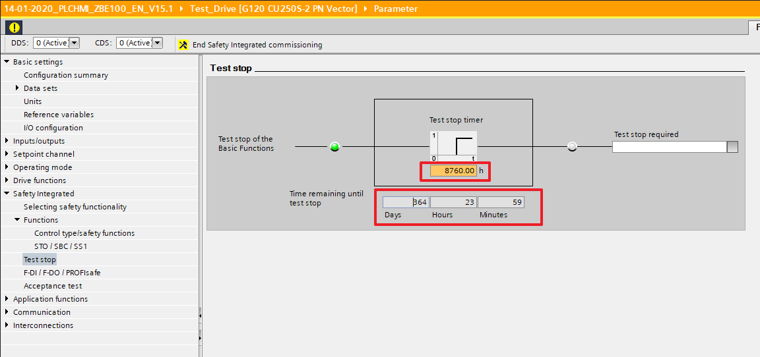

Once everything is finished Click ‘End safety Integrated Commissioning.

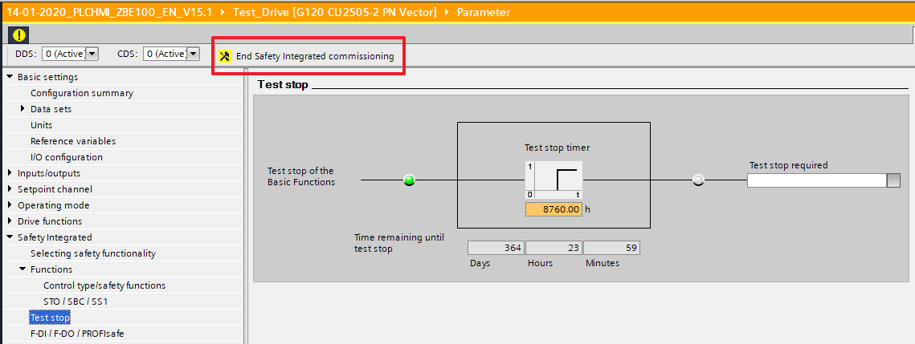

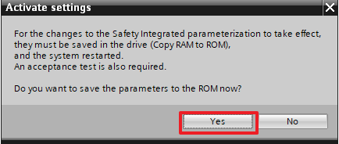

**LED status for safety integrated**

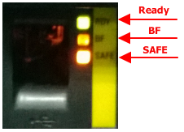

* If no safety integrated functions were configured, then the SAFE-LED will be OFF.
* If safety integrated functions were configured and no emergency is active then the SAFE-LED will be ON.
* If the safety integrated is active and an emergency stop is active, then the SAFE-LED will be FLASHING

# Low Speed Management

The inverter can be used in the emergency stop loop in parallel of the doors during web introduction. Two digital outputs will be inserted in each channel of the emergency stop loop. This can configure in following way.

Choose “Extended functions” and “Actual valve sensing”

Then “Enable” the Safety functions.

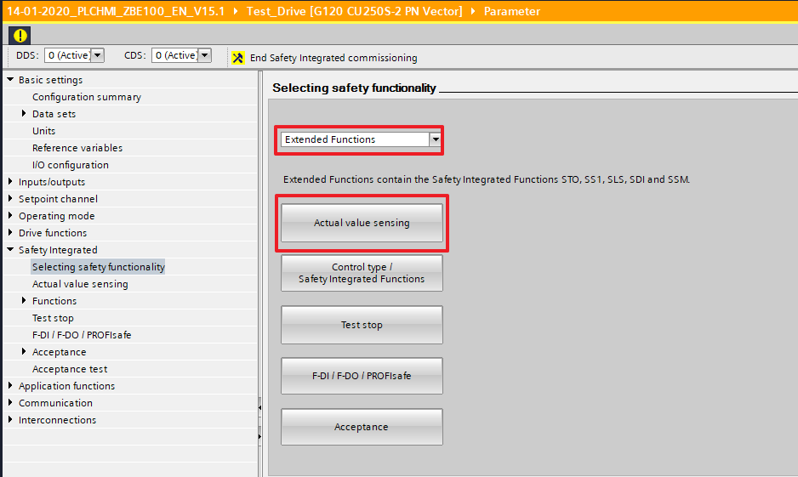

Click the Icon to enter Actual Value sensing

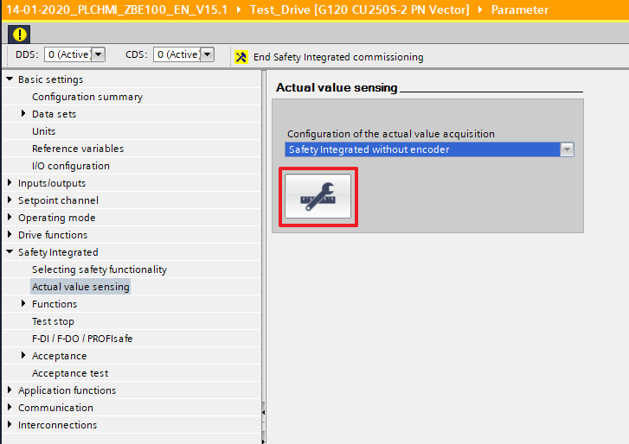

Set “2” for “Number of motor revolution x pole pair number”’ if the motor is with 2 pole pair number (1500 rpm) and “1” for “Number of load revolution”

Leave the factory setting for “Act. Value tolerance” if there is no safety integrated faults.

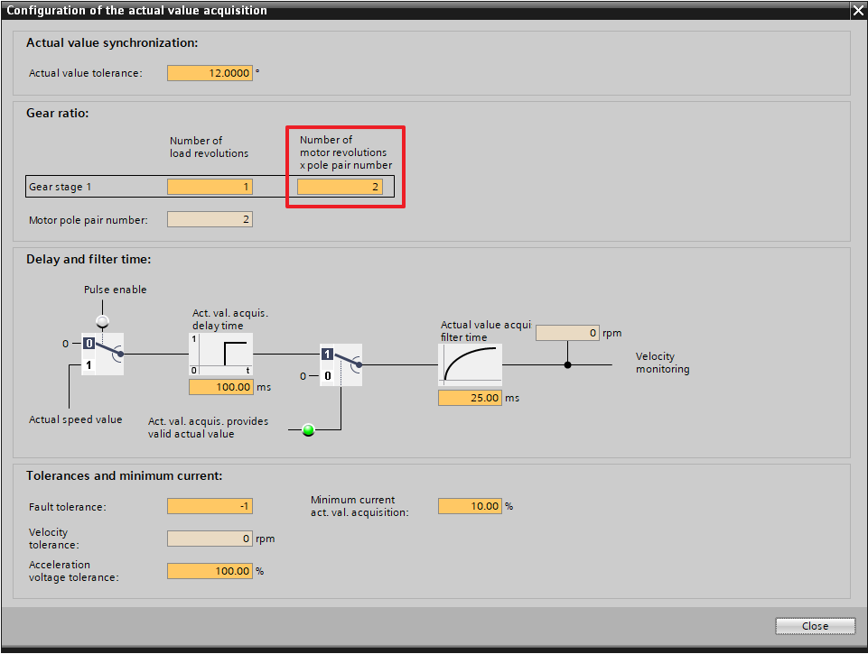

Select Control Type for SS1 and SLS here.

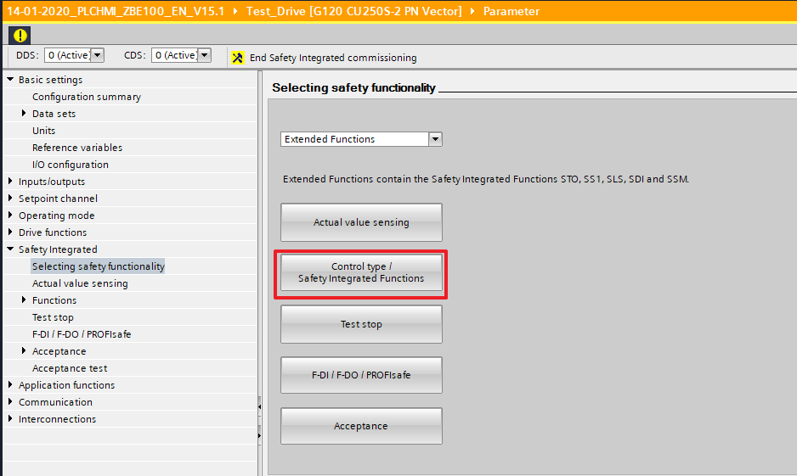

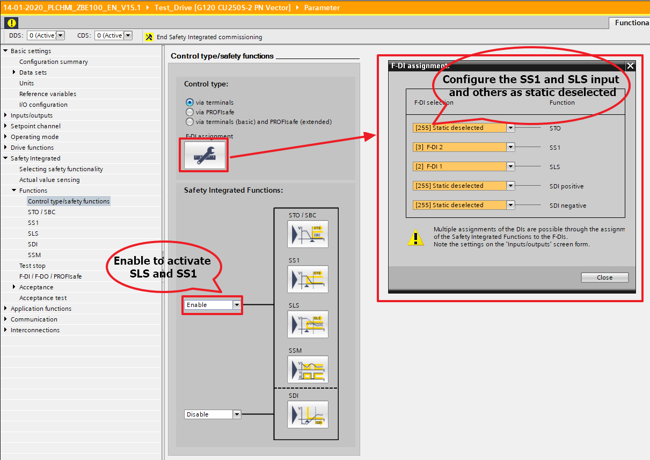

Select ‘SAM/delay time’ and Delay time 500 ms.

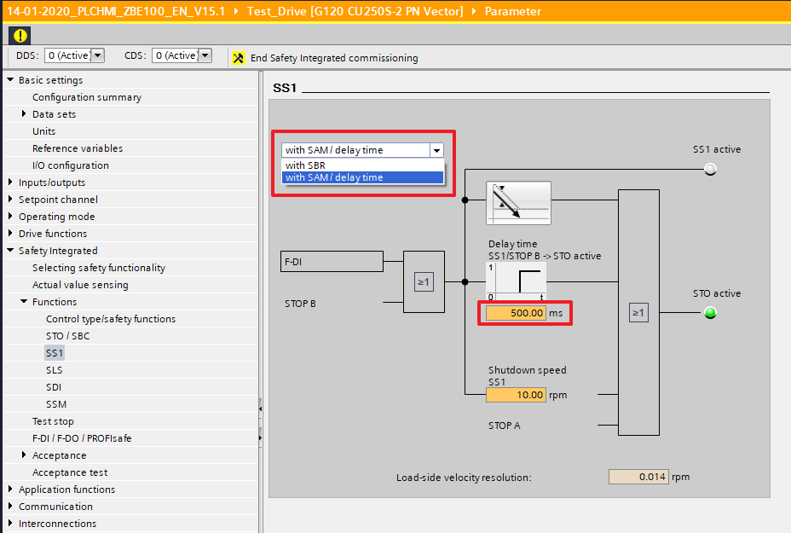

For SLS Select the %speed limit limitation and the maximum RPM.

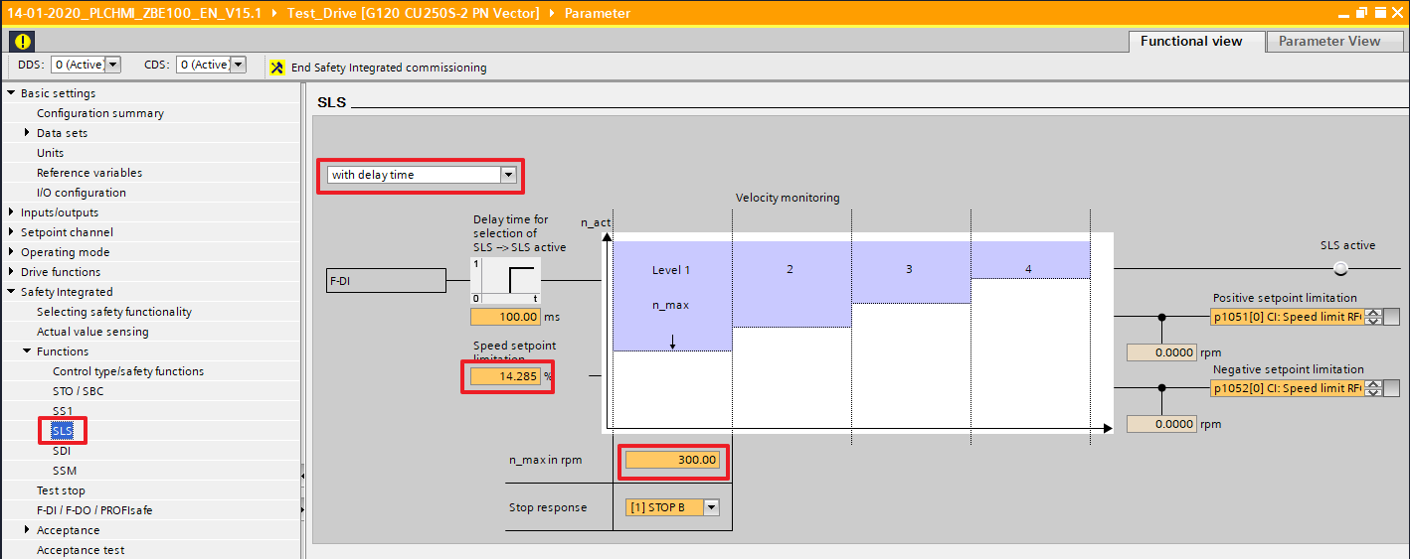

The bit for the “Test stop selection” must come from the emergency stop on the inverter terminal. Parameter r723.4. Time value “8760h”

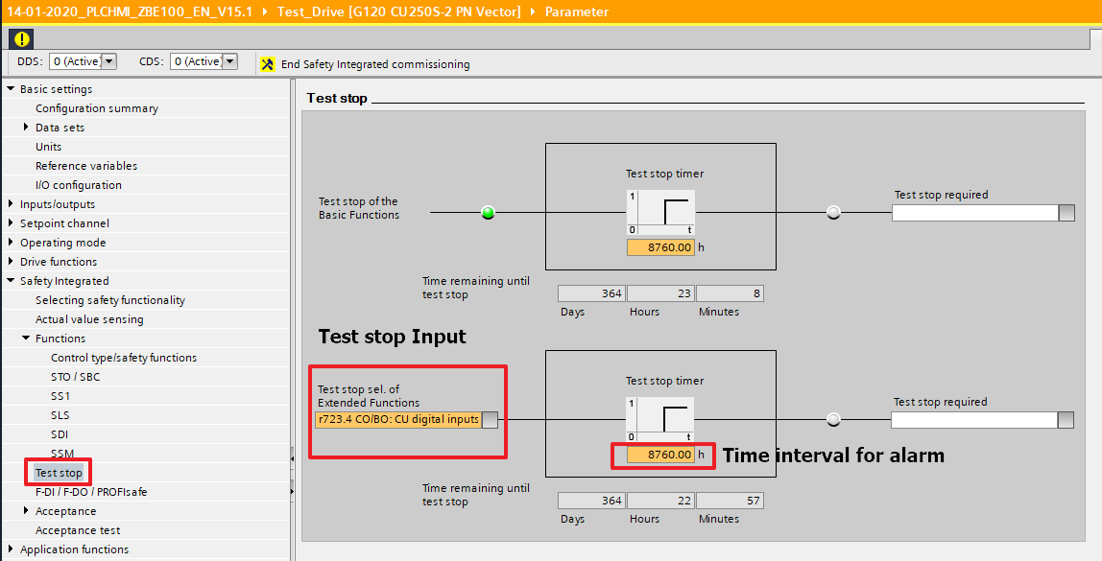

To reset the safety alarm, you should close the door, do an emergency stop. Wait 5 second before to release the E-Stop, and reset the inverter as usual.

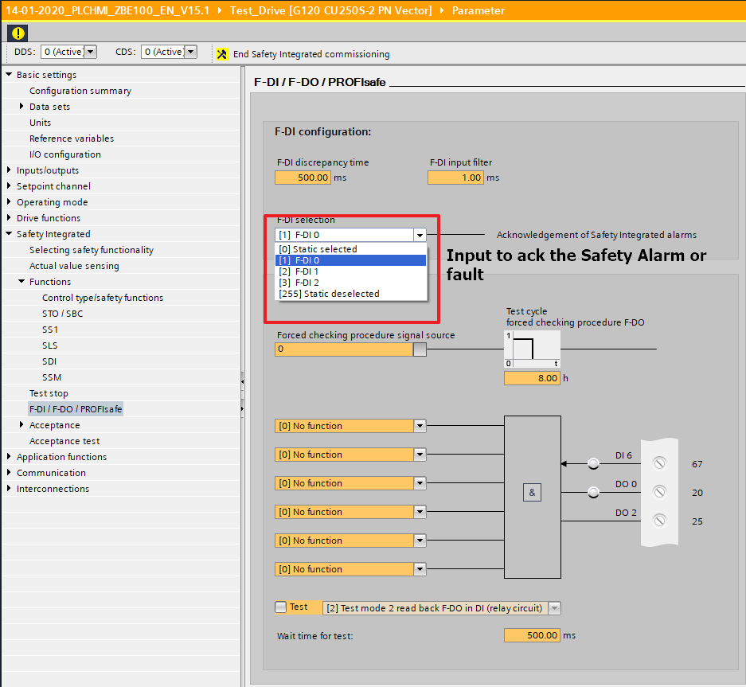

After completing the above steps Click ‘End Safety Integrated Commissioning’.

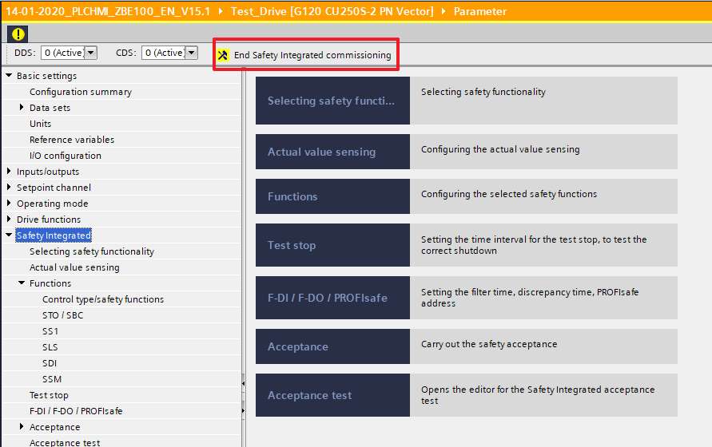

Then a popup appears to save the parameters in EEPROM.

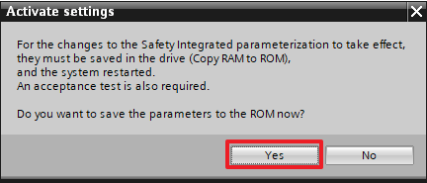

**IMPORTANT:**

This is the speed limitation (20m/min) in % P9531 (maximum speed in SLS)

This is the speed limitation (20m/min) in % P9531 (maximum speed in SLS)

This is the speed limitation (20m/min) in % P9531 (maximum speed in SLS)

This is the speed limitation (20m/min) in % P9531 (maximum speed in SLS)

This is the speed limitation (20m/min) in % P9531 (maximum speed in SLS)

This is the speed limitation (20m/min) in % P9531 (maximum speed in SLS)

BEFORE TO SAVE IN THE EPROM, DON’T FORGET TO COPY THE PARAMETERS

THE GAIN FOR SPEED REGULATION MUST BE ADJUSTED PROPERLY IN ORDER TO HAVE RELIABLE SLS FUNCTION.

THE GAIN FACTORY VALUE (20) IS TOO HIGH AND HIGH GAIN LEADS TO RANDOM SAFETY INTEGRATED FAULTS WHEN SLS IS ACTIVE WITH LOW FREQUENCY (0 to 1m.min)

= to the maximum speed

# Current Fault

## Diagnostic with lamps on the control unit



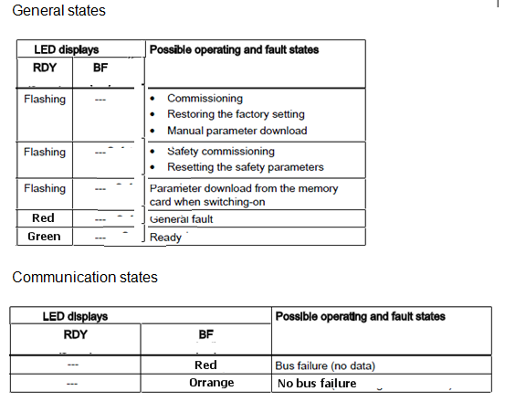

# Parameters Backup Saving

## Backup in EEPROM

The parameters backup from RAM to ROM is done by changing the parameter value of p0971: enter 1 in this parameter to launch the transfer. When it's finished, the parameter goes back automatically to 0.

## MMC Management

On MMC can be used to back up the inverter data. This can be configured in the following way,

1. To back up the inverter data to MMC



1. To retrive the MMC data to the inverter memory



# Sensorless Vector Control (SLVC):

This section gives details about configuring a drive for Sensorless vector control.

The following procedures can also be referred for commissioning using Vector control using Sensor, if the encoder selection is taken care properly.

In the following section detailed explanation about Motor Identification and speed optimization can be found. In section 3 - Quick commissioning using starter only a briefing was available.

**Important Note:**   
  
SLVC should not be used:   
1. where the motor inverter power ratio is less or more than 1:4  
2. When the maximum frequency is greater than 200Hz  
3. On multi – motor applications  
4. If a contactor is placed between the inverter and the motor; respectively the contactor must never be opened whilst the inverter is running.  
5. for hoisting applications

Sensorless Vector Control (SLVC) operation relies on continuous recalculation of the rotor position, and if, for any reason, the motor position information is lost (“Loss of Orientation”) the response of the drive is unpredictable. Loss of orientation can be caused be an incorrectly commissioned motor, loss of motor temperature information following power failure, or similar disturbances. When the frequency inverter loses its orientation, then the motor can no longer be stopped with OFF1 or OFF3. This is the reason that when commissioning the drive, either OFF2-function or the pulse inhibits must also be connected-up.

**Recommended means of commissioning**  
  
for correct operation under SLVC control it is extremely important that the motor data is correctly entered and that the motor identification is carried out. The order this is carried out is also important as the quick commissioning procedure provides the initial motor model, and the motor identification measurements refine this.  
  
The procedure for doing this is as follows:   
  
  
**1. Quick Commissioning and setting initial motor model**  
  
P0003 = 2 (allows user access level 2)   
  
P0010 = 1 (Quick Commissioning)   
  
P0300 and the following: Motor data according to motor nameplate  
  
P0700, P1000, P1080/P1082, P1120/P1121 control selection, setpoint selection, Fmin/Fmax, ramp times etc.  
  
P1300 = 20 Sensorless Vector Control  
  
P1910 = 1 (A0541 will appear at this point > see also: 2.Motor Identification using)   
  
P3900 = 1  
“busy” will appear on the BOP for approximately 1 minute, or longer a very large inverters, while the motor parameters are being calculated. After this A0541 will now be flashing on the BOP.  
This completes the quick commissioning and the initial motor model is now complete.  
  
  
**2. Motor Identification using P1910**  
  
Two automated series of measurements must now be carried out.  
  
**Note:** The measurements should be carried out on a **cold** motor. It is also necessary to ensure that the motor ambient temperature is correctly entered in P0625. Factory setting = 20°C. A potentially necessary change must be done after the quick commissioning has been completed (P3900) but before the motor identification measurements are carried out.  
  
P1910 = 1. Give a RUN command: This initiates the motor identification measurements.  
  
A0541 will continue to flash; a number of measurements are made by pumping current into the motor for short bursts making an audible hum. This is followed by “busy” on the BOP while the internal motor parameters are calculated.  
  
If you get a fault message F0041 (Failure, motor data identification), this means that the measured value does not match the expected value from the initial motor model. In this case, check the wiring (particularly star / delta connection) and also the parameter values entered. If all of these are ok, then you should try to run the drive, unloaded, in V/f control (set P1300 = 0), with a setpoint of ca. 80% of motor rated frequency. Look at the value for output current (r0027) and enter this as the motor magnetisation current in P0320 (as % value of motor rated current, P0305) and recalculate the motor parameters (set P0304 = 1).  
  
The identification of saturation curve, P1910 = 3, can improve the performance: This should be done after 1910 = 1.  
Once P1910 is set to 3, A0541 will appear anew. Now give RUN command. The behaviour will be similar to the description above.  
  
At this point, the inverter can be run under SLVC. However an optimisation procedure is recommended to get best regulation.

**3. Speed control optimization using P1960**  
  
When **speed controller optimisation** is enabled (**P1960 = 1**) the warning A0542 will become active. When the drive is next started it will do the optimisation tests.  
The drive will accelerate the motor to 20 % of P0310 (rated motor frequency) using the ramp up time P1120 and then under torque control go to 50 % of P0310 (rated motor frequency). The drive will then ramp back down to 20 % using the ramp down time P1121.  
This procedure is repeated several times and then average time taken.  
When the test is complete P1960 will be cleared to zero.  
  
Note:   
The speed loop optimisation may not be suitable for some applications due to the nature of the test i.e. accelerating under torque control from 20 % to 50 %.  
  
  
  
**4. Manual speed control optimization**  
  
a. Motor Model  
  
SLVC requires a good motor model. A good measure of this is **r1787** (Output of Xm adaptation). This should be below +/- 15%. If this not the case you may need to improve the model.  
  
The motor model can be improved by measuring the magnetisation current. Use the procedure described in Motor identification to find the magnetisation current. If the procedure cannot be followed (e.g. because the motor cannot be decoupled form load) then you should try values of magnetisation current (set P0320 followed by P0340 = 1 to recalculate the motor model) until you find that r1787 is in an acceptable range.  
  
Note: once you have established the correct magnetisation current for a motor, this will be more or less valid for all motors of that type, so it should not be necessary to carry out these measurements for each motor, but rather set P320 appropriately.  
  
  
b. Performance  
  
The motor identification will set initial values for the Sensorless vector control which will allow the motor to be run up to 50 Hz. In order to get good vector performance, it is necessary to optimise the vector control loop according to the mechanics of the motor / load system.  
  
The following parameters can be adjusted by the user to improve performance. For best results you should use an oscilloscope to measure the effect of any adjustments:   
  
P0003 = 3  
P0342: motor / load inertia ratio in combination with P1496 (scaling acceleration pre-control)   
P1470: SVC P gain  
P1472: SVC I term  
P1520/P1521: Torque limits  
P1610: SVC open loop boost  
P1750: enable observer model  
  
P0342 - The total/motor inertia ratio - should be appropriately set where this is known or can be estimated as described. This is used in conjunction with P1496 to generate an extra torque to overcome load inertia. For best results set P1496 = 100% and try values of P0342 = 1, 3, 6 etc. You should see that the performance becomes better with increasing values until the value is set too high and causes instability. This is normally only useful for system where a pulse of torque is required to start an inertial load moving, but not subsequently required.  
  
P: P1470 - Gain speed controller (SLVC) and I: P1472 - Integral time n-ctrl. (SLVC) – These are initially set to allow a large range of applications. The optimal settings are dependent on the mechanical system. Good results can be achieved by increasing the P-term and decreasing the I-term while observing the system behaviour. Ideally this should be done by looking at the unfiltered output frequency (r0066) on a scope via the analogue output (P0771 [0] = 66). It is also useful to monitor the output current, either current, either with a clamp as shown or using a second analogue output (P0771 [1] = 27).  
  
Here are examples of how changing the values of P1470 and P1472 affect a resonance while ramping up. In each case trace (A) is the motor current using a clamp and trace (B) is the unfiltered output frequency (r0066)

<http://support.automation.siemens.com/WW/llisapi.dll/csfetch/7494205/Picture_1.jpg>

P1470 = 12; P1472 = 80 ms

<http://support.automation.siemens.com/WW/llisapi.dll/csfetch/7494205/Picture_2.jpg>

P1470 = 6; P1472 = 25 ms  
  
P1511 - additional torque setpoint.  
This is particularly useful for applications where instantaneous torque is required (e.g. lifting drive). This can be connected to a value as follows: P1511 = 2890 and set P2890 = xx% (e.g. 40%).  
  
P1520 - Upper torque limit and P1521 - Lower torque limit  
reducing these can reduce instability, while increasing can give better dynamic performance.  
  
P1610 - SVC boost for open loop operation.  
Sets continuous torque boost in lower speed range of SLVC (Sensorless vector control). Value is entered in [%] relative to rated motor torque r0333.  
The default is 50% and this can be increased to increase low speed torque.  
  
P1750 - Control word of motor model  
this parameter controls the operation of the Sensorless vector control (SLVC) at very low frequencies.  
Setting P1750.0 = 0 allows the observer model to be used from standstill provided that the frequency setpoint is greater than 5 Hz. Setting P1750.1 = 0 allows the observer model to be used when passing through 0 Hz. In general using the observer model provides best performance and avoids the transition between open loop and Sensorless Vector Control at 5 Hz.  
  
P1755 - switchover frequency for vector control.  
This is the base frequency or cut in point for the vector model. The 5 Hz default setting operates V/f mode both sides of zero. E.g. at default the control mode between -5 Hz to +5 Hz will return to V/f mode (P1300 to 1). This value can be reduced below its 5 Hz default setting on large motors to allow full vector control below the 5 Hz default. However this should not be reduced below 2x motor rated slip frequency. The reason for this setting is that it is difficult to maintain accurate motor modelling with small motor currents.  
  
Note that optimised performance will depend on what you are trying to achieve (e.g. this might be different depending on whether you require very good speed holding or high torque at low speeds). You should always test and measure against this.  
  
Please don't forget to permanently save the data with Ram to Rom (P971 = 1).  
  
Before leaving site, you should always test your settings across a range of loads and also in worst case conditions.  
Try shock loading, coupling and decoupling load, or if this not possible run the motor up to a given speed, set the ramp times P1120/P1121 to 0, and give a frequency setpoint step change of a few Hz (add fixed frequency using DIN).  
  
  
The optimised values you have achieved should be useable on any machine of identical mechanical and electrical construction. However we always recommend carrying out the motor identification measurements (1910 = 1 & 3). After this the values for P1470 etc. can be entered without the need for a full optimisation.

# Minutes of Reception for Safety (Need to update)

## Acceptance test for SS1

The test includes the following steps.

| No. | Description | Status |
| --- | --- | --- |
| 1. | Initial state: | |
| * r52.0 = 1 (Drive ready) |  |
| * SS1 function enabled   + via F-DI0 (p9603.3 and p9803.3 =1) |  |
| * SS1 leds is light up |  |
| * No safety faults and alarms |  |
| * r9772.0 and r9772.1 = 0 (STO deselected and inactive) |  |
| * r9772.2 and r9772.3 = 0 (SS1 deselected and safety monitoring ramp inactive) |  |
| 2. | Run the drive (ON command) |  |
| 3. | Ensure that the correct drive is running |  |
| 4. | Select SS1 during the drive is running (By pushing emergency stop button for example) |  |
| 5. | Check the following: | |
| * Motor speed declines according to chosen ramp time (p9681 and p9881) |  |
| * Below the parameterized minimum speed (p9682 and p9882) the motor coasts to a standstill |  |
| * The motor is stopped |  |
| * No safety faults and alarms |  |
| * r9772.1 = 1 (STO active) |  |
| * r9772.2 = 1 (SS1 selected) |  |
| * STO & SS1 leds on inverter are blinking |  |
| * ES led on inverter is light up |  |
| 6. | Deselect ON command and SS1 (Acknowledge Emergency stop relay) |  |
| 7. | Check the following: | |
| * No safety faults and alarms |  |
| * r9772.1 = 0 (STO inactive) |  |
| * r9772.2 = 0 (SS1 deselected) |  |

## Acceptance test for SLS

The test includes the following steps.

|  |  |  |  |  |
| --- | --- | --- | --- | --- |
| No | Action | Description | State expected | Result |
| 1 | Pass the machine in test mode from the HMI | Necessary conditions  Transport stopped  No emergency or selected motor fault  Engineer access on HMI  At least one safety grid open  Start test sequence from the HMI | TEST MODE IN PROGRESS |  |
| 2 | Selected internal setpoint on HMI | Set the speed setpoint to 15m/min | Speed setpoint of selected motor = 15m/min |  |
| 3 | Manual start of selected motor | Select motor on the HMI  - Start command | Selected motor start at 15m/min |  |
| 4 | Increase of the speed | Set speed setpoint at 20m/min | Selected motor at 20m/min |  |
| 5 | Increase of the speed | Set speed setpoint at 25m/min | Trigger of the emergency stop loop |  |

|  |  |  |
| --- | --- | --- |
|  | Description | Result |
| AUDIT | Trigger of the emergency stop relay (visual audit) |  |
| Emergency stop fault on HMI |  |
| Over speed fault of selected motor on HMI |  |
| All inverters on SS1 state (led SS1 blinking on the inverter) |  |